**Title:- Snapshot’s Deletion**

Step1: - **Create EC2 Instance**

### **Sign into the** **AWS Management Console:**

Log in to your AWS account.

### **Navigate to the EC2 Dashboard:**

In the AWS Management Console, find and select the "EC2" service.

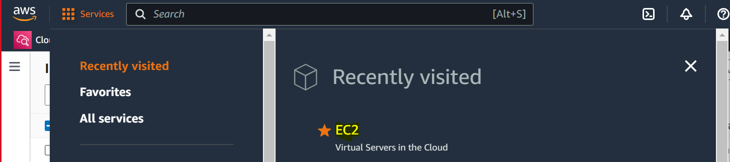

### **Launch Instance:**

Click on the "Instances" option on the left sidebar and then click the "Launch Instance" button.

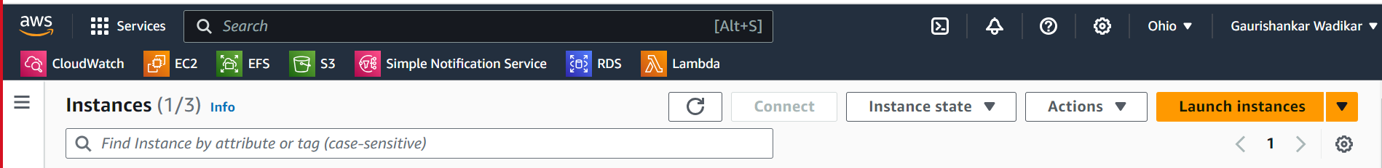

### **Choose an Amazon Machine Image (AMI):**

* Select an AMI that best suits your needs (Amazon Linux, Ubuntu, Windows Server, etc.).

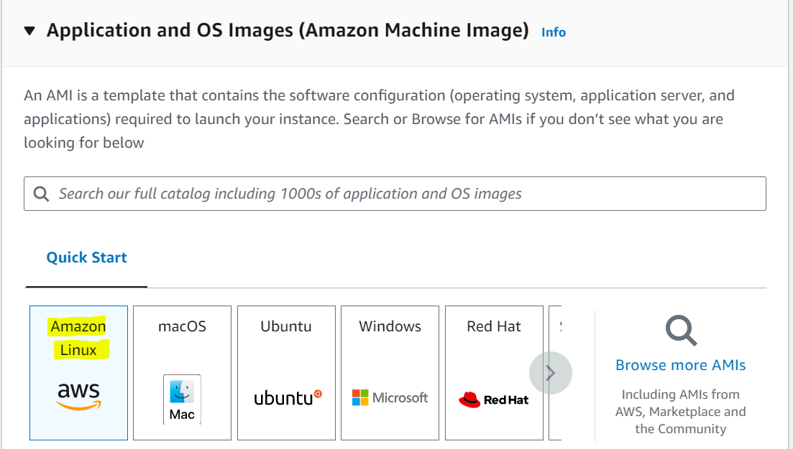

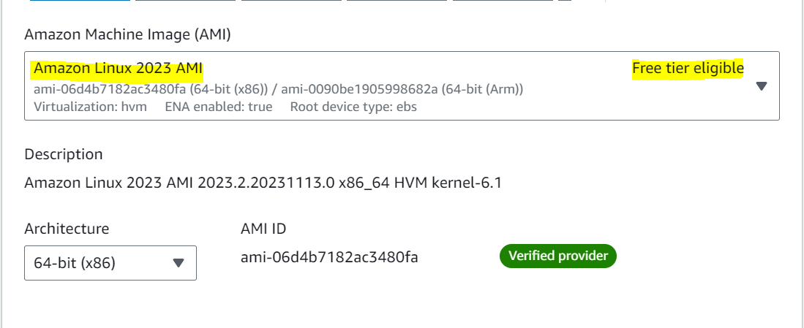

### **Choose an Instance Type:**

* Select the instance type based on your workload requirements (e.g., t2.micro, t3.medium, etc.). Instance types vary in terms of CPU, memory, storage, and networking capacity.

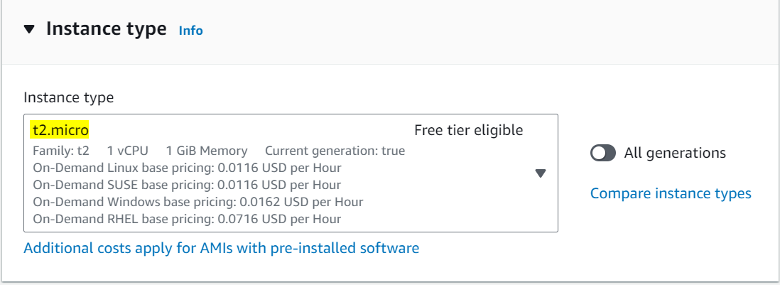

### **Key Pair:**

* Select an existing key pair or create a new one. This key pair will be used to SSH/RDP into your instance securely.

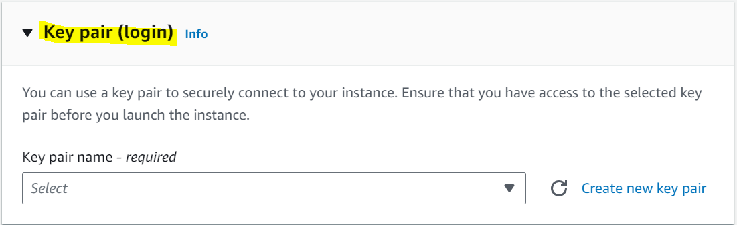

### **Configure Instance:**

* Configure instance details like the number of instances you want to launch, network settings (VPC, subnet), IAM role, etc.

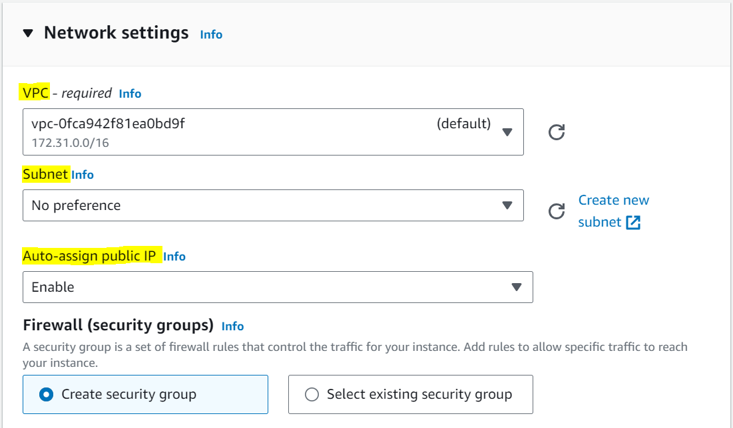

### **Add Storage:**

* Define the storage requirements for your instance. You can add or modify the default storage settings (EBS volumes) based on your needs.

### **Configure Security Group:**

* Create a new security group or choose an existing one. Security groups act as virtual firewalls controlling inbound and outbound traffic to your instance.
* 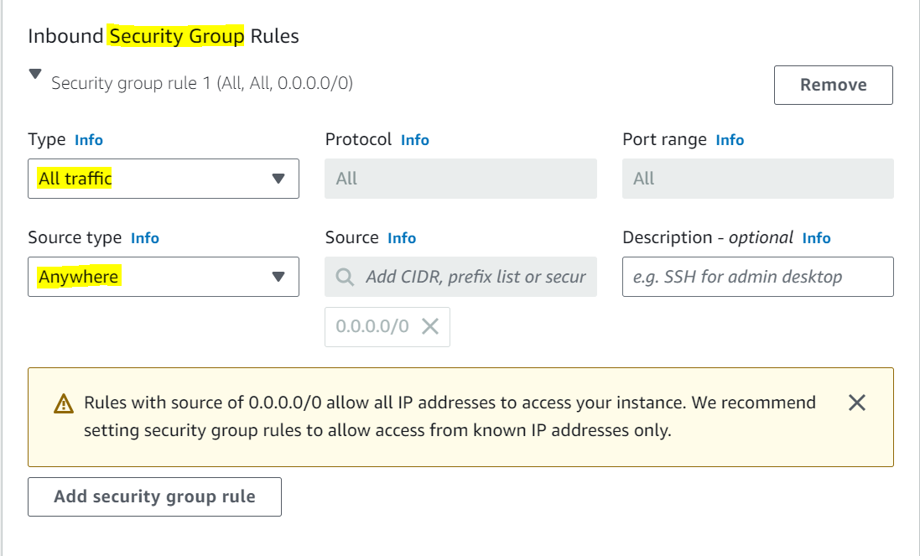

### **Review and Launch:**

* Review the configuration details of your instance.
* You can modify any settings at this stage if needed.

### **Launch Instance:**

* Click the "Launch" button.
* AWS will prompt you to select or create a key pair if you haven't already. This key pair will be used for securely accessing your instance.



### **View Instances:**

* After launching, go back to the EC2 dashboard and click on "Instances" to view the status of your newly created instance.

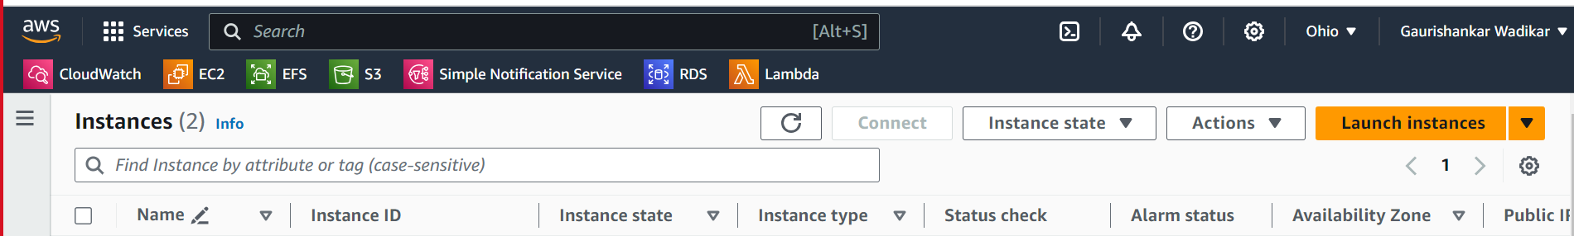

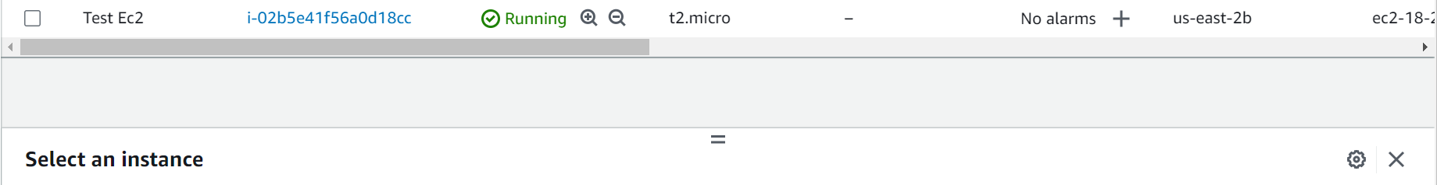

Step2:- **Create Snapshot**

### **Navigate to the EC2 Dashboard:**

Find and select the "EC2" service.

### **Locate the Instance:**

* Click on "Instances" in the left sidebar.
* Select the EC2 instance for which you want to create a snapshot.

### **Identify Attached Volumes:**

* Once you've selected the instance, go to the "Description" tab below to view the attached volumes.

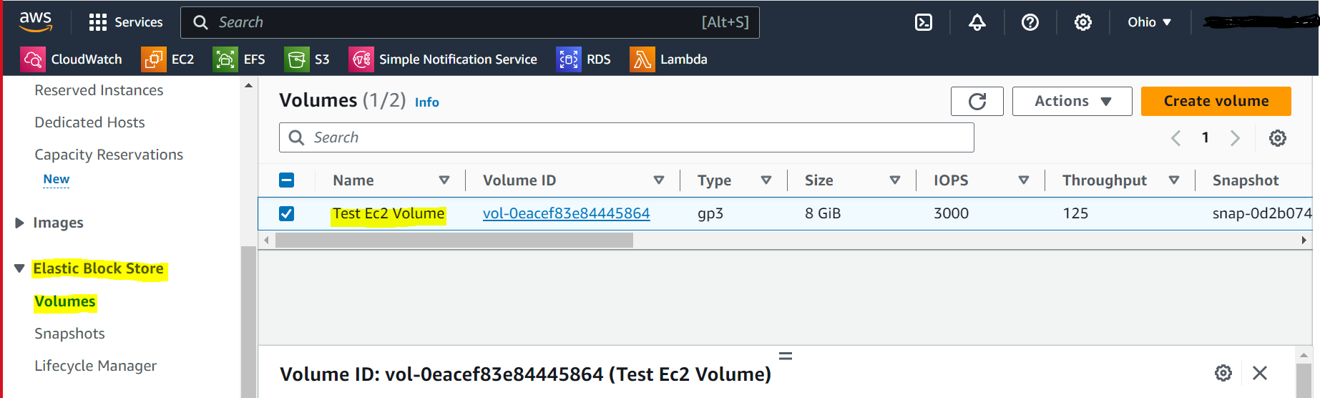

### **Take Snapshot:**

* Right-click on the volume(s) you want to snapshot.
* Choose "Create Snapshot" from the context menu.

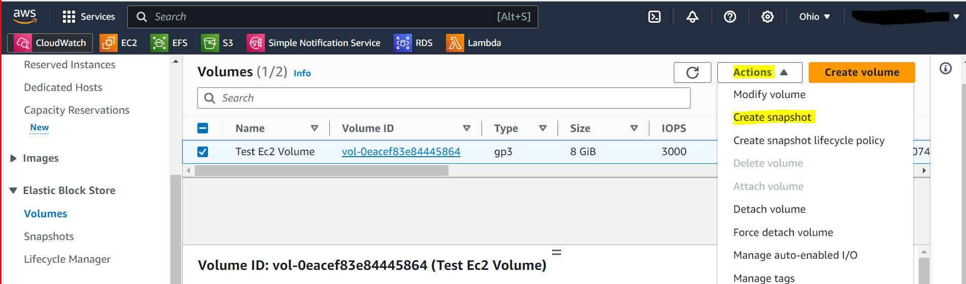

### **Define Snapshot Details:**

* Enter a descriptive name and description for the snapshot.
* Review other settings (like encryption, tags, etc.) if needed.

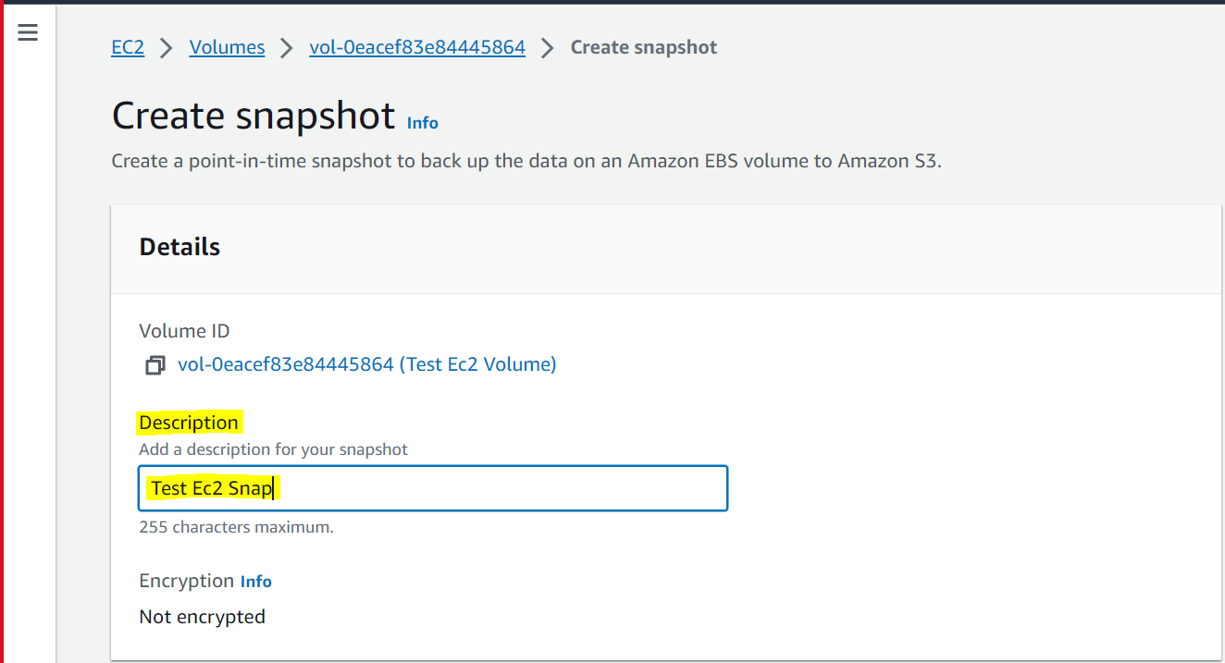

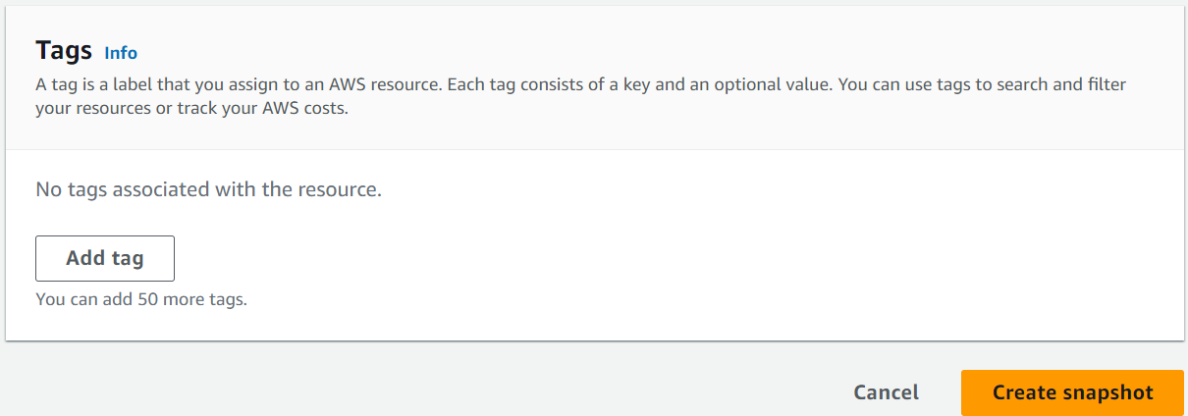

**Create Snapshot:**

* Click "Create Snapshot."
* AWS will start the process of creating the snapshot.



Step3:- **Delete Single Snapshot Manually**

### **Navigate to the EC2 Dashboard:**

Find and select the "EC2" service.

### **Access Snapshots:**

In the EC2 dashboard, locate and click on "Snapshots" in the left sidebar under the "Elastic Block Store" section.

### **Locate the Snapshot:**

* Find and select the snapshot you want to delete from the list displayed.
* Ensure it is the correct snapshot associated with the EC2 instance you want to remove.

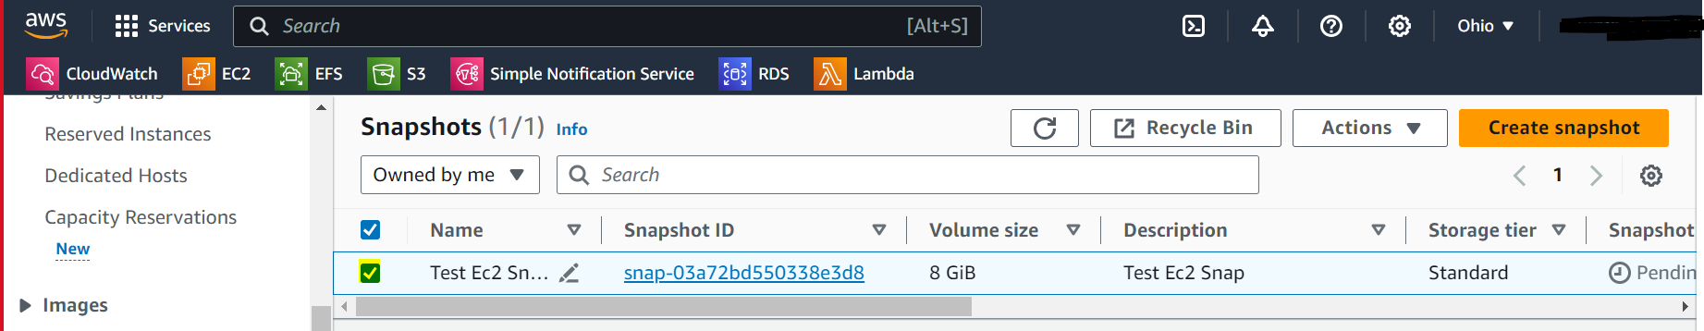

### **Delete Snapshot:**

* Once the snapshot is selected, click on the "Actions" dropdown menu at the top.
* Choose "Delete Snapshot" from the options.

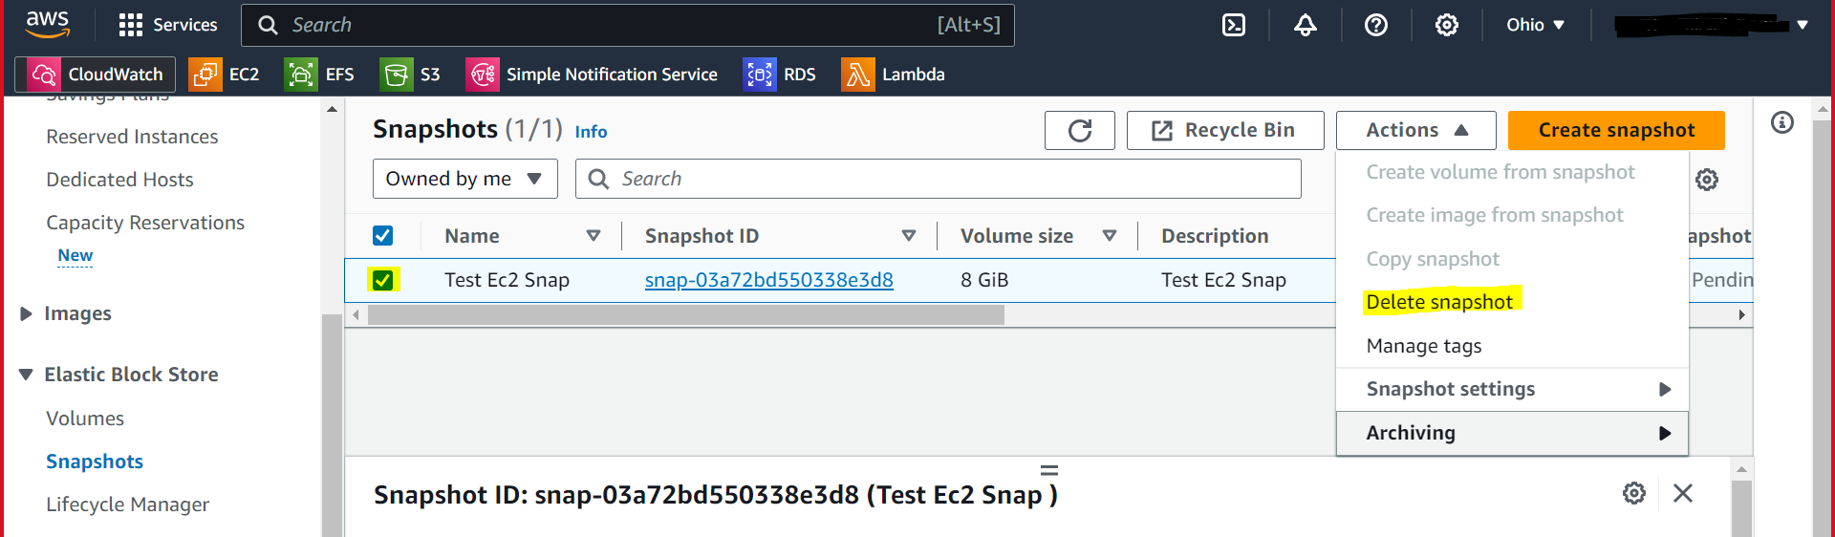

### **Confirm Deletion:**

* AWS will prompt you to confirm the deletion. Review the details and click "Yes, Delete" or "Delete" to confirm.

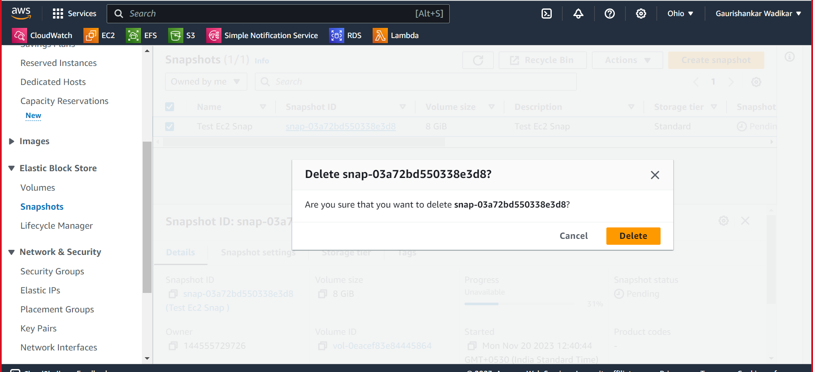

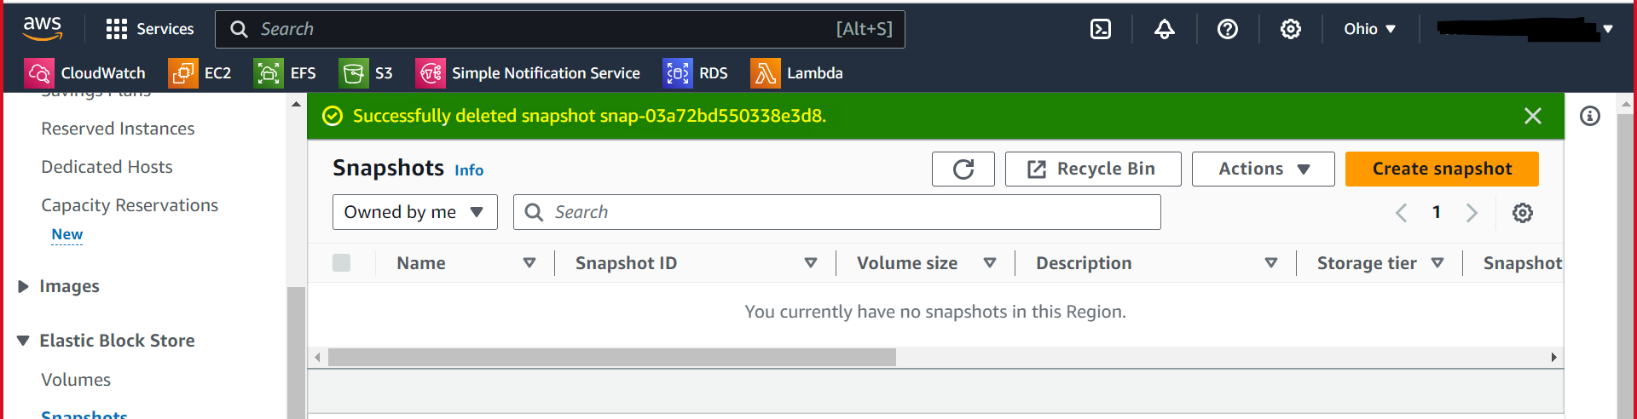

Step4:- **Delete Multiple Snapshots Manually**

### **Select Snapshots to Delete:**

* Check the checkboxes next to the snapshots you want to delete. You can select multiple snapshots by clicking on each checkbox.
* Alternatively, you can use the checkboxes in the table header to select all visible snapshots.

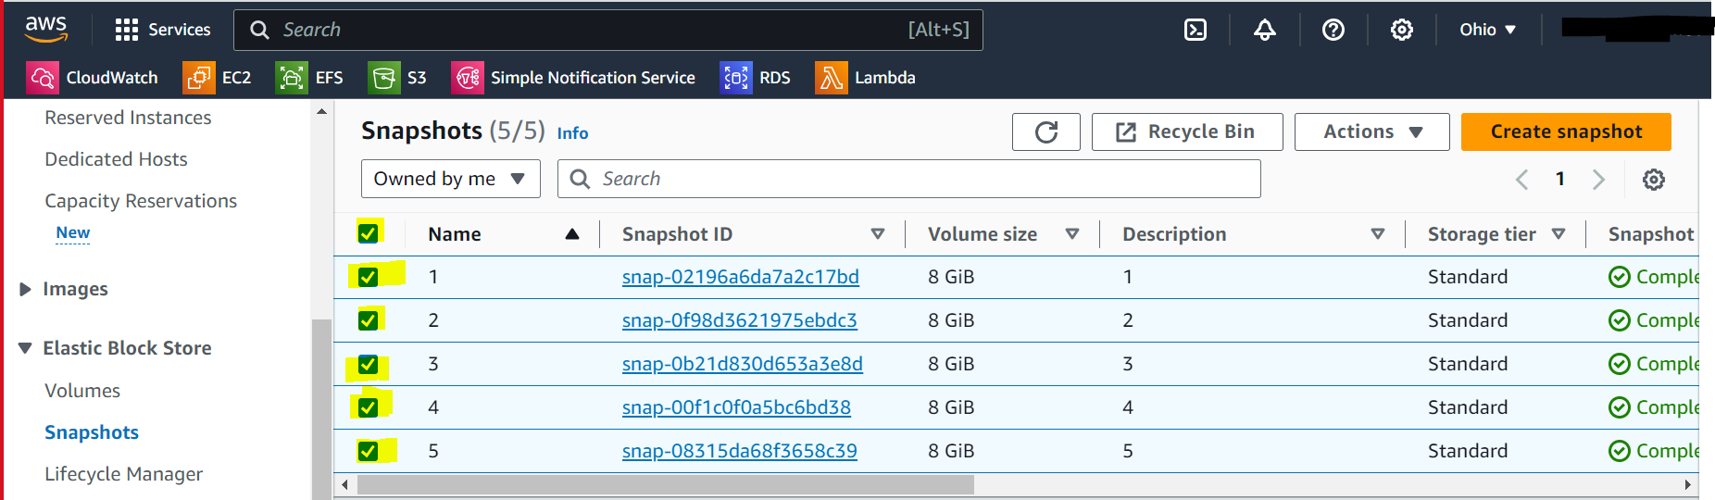

### **Delete Selected Snapshots:**

* Once you've chosen the snapshots, click on the "Actions" button above the snapshots list.
* From the dropdown menu, choose "Delete Snapshot(s)."

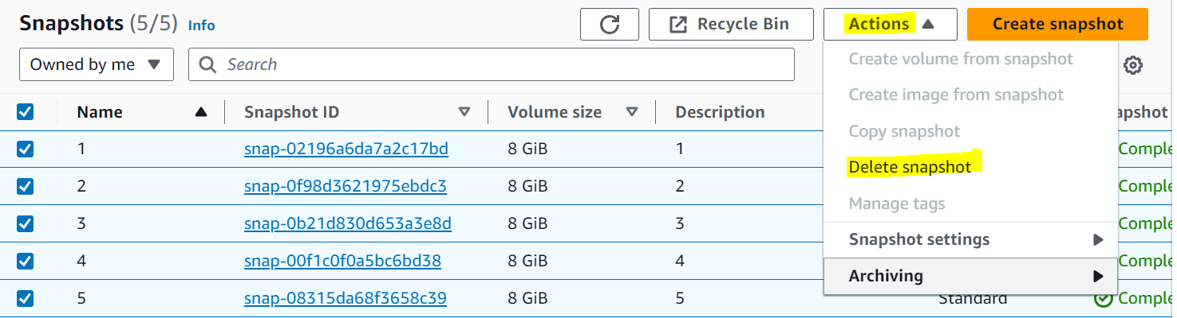

### **Confirmation:**

* AWS will prompt a confirmation window showing the snapshot IDs you've selected for deletion.
* Review the list and click "Yes, Delete" or "Delete" to confirm and delete the selected snapshots.

